**TRABAJO DE MOODLE**

**GUÍA PARA HACER MOOC CON COURSE BUILD V1.5.1**

1. Descargar los siguientes archivos
   1. Python el link de descarga es <https://www.python.org/downloads/>

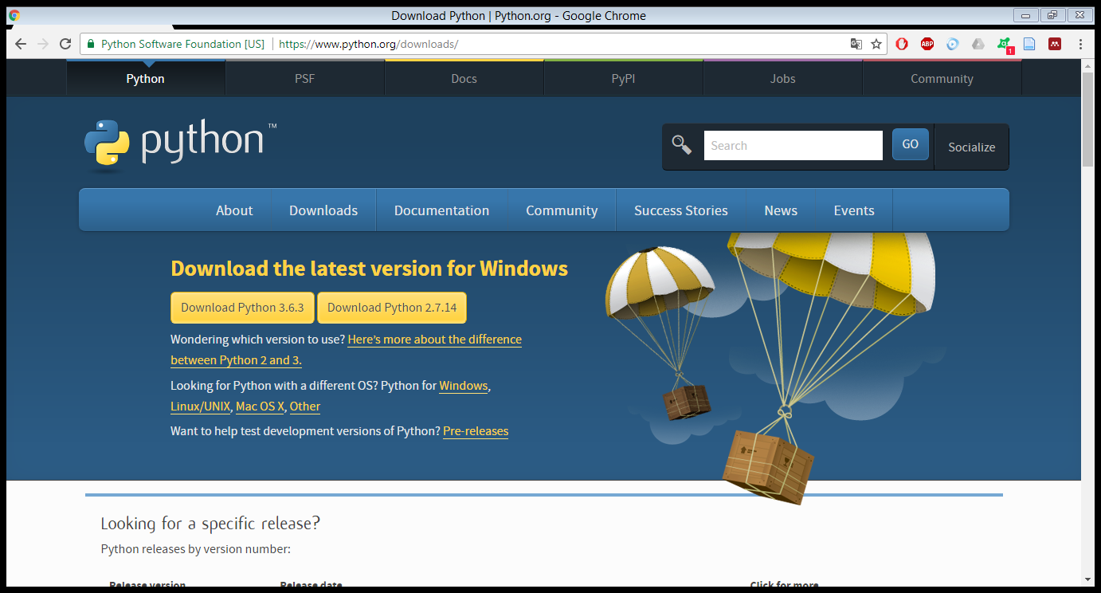

* Escogemos la versión 2.7.8

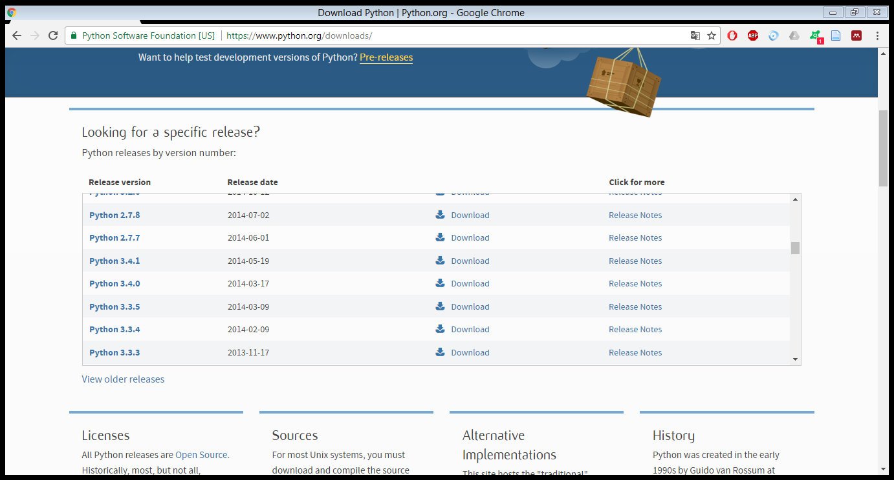

* Se escoge Windows x64 MSI installer

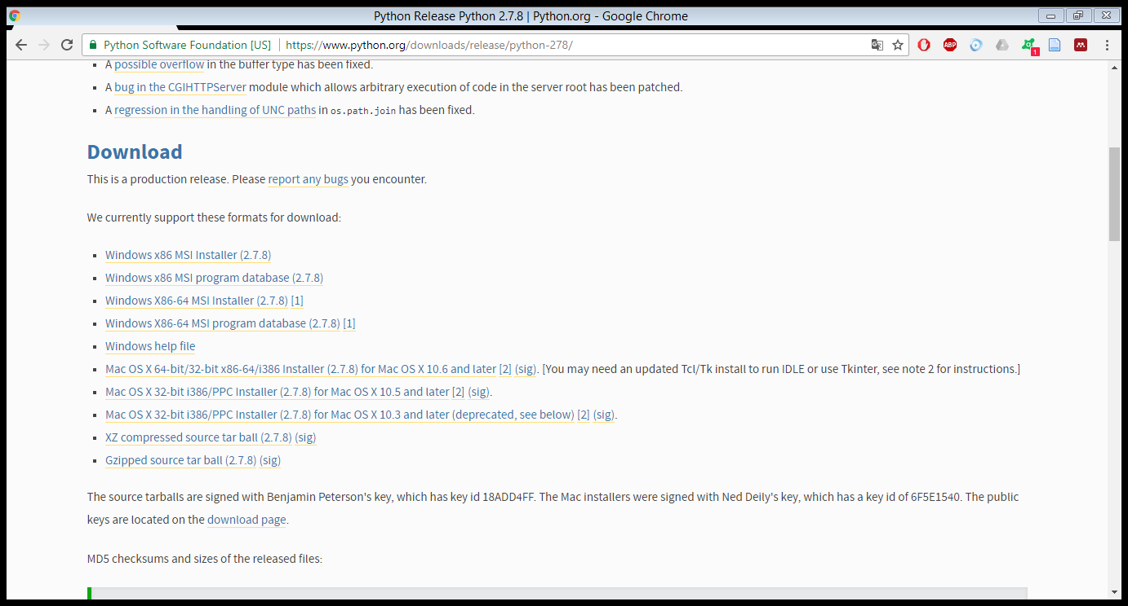

* Una vez descargado lo instalamos
* Le damos en ejecutar

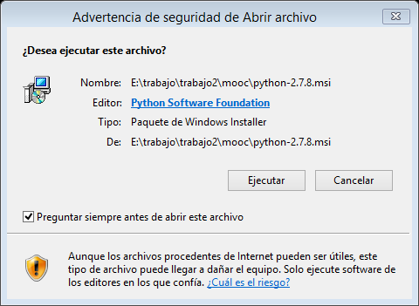

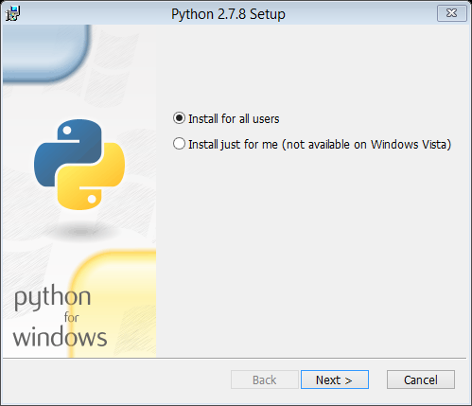

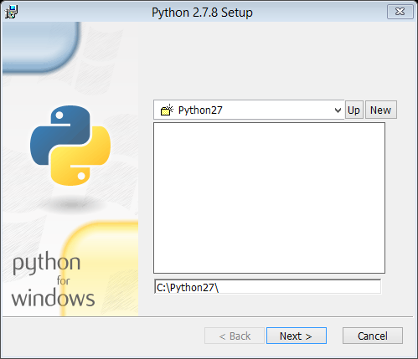

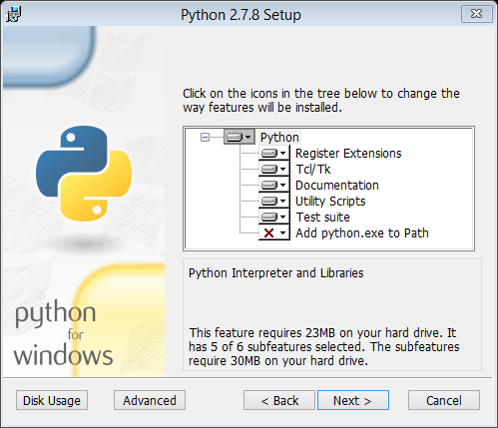

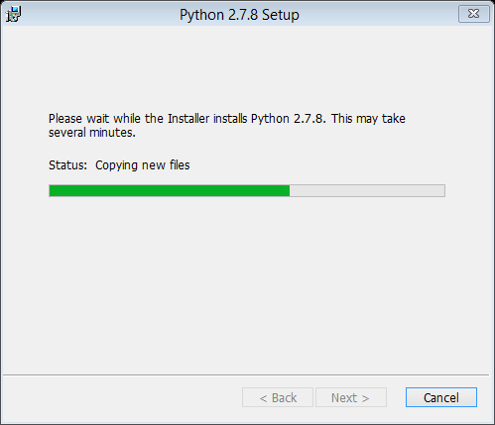

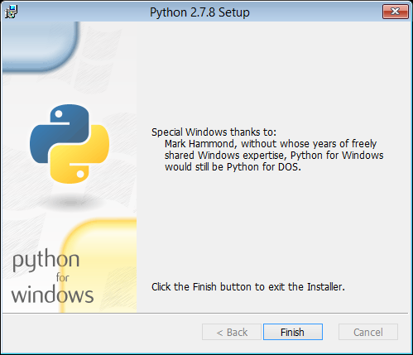

* 1. Descargamos ahora el google app engine para python

<https://cloud.google.com/sdk/?hl=en_US>

<https://cloud.google.com/appengine/downloads?csw=1>

<https://cloud.google.com/sdk/docs/>

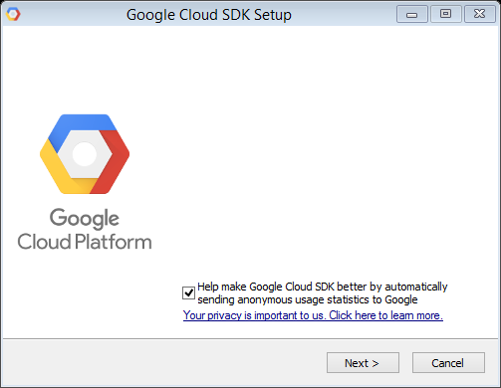

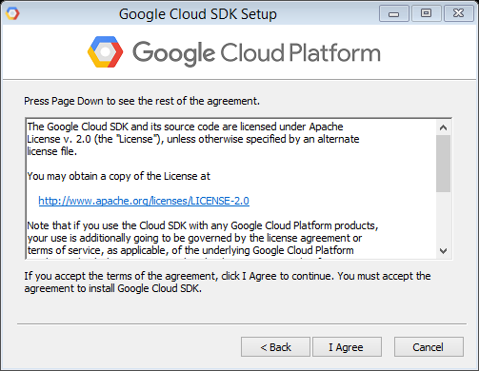

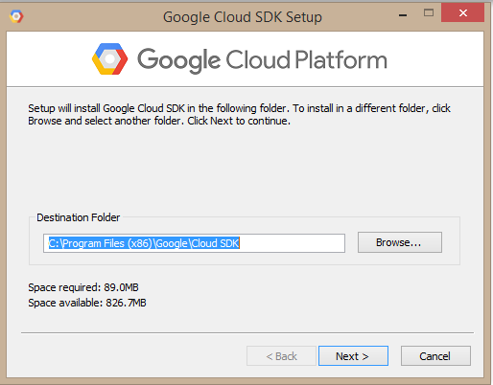

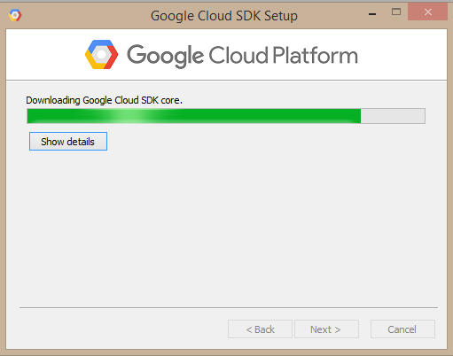

* 1. Descargamos google course builder
* Descargamos la course Builder v.1.5.1

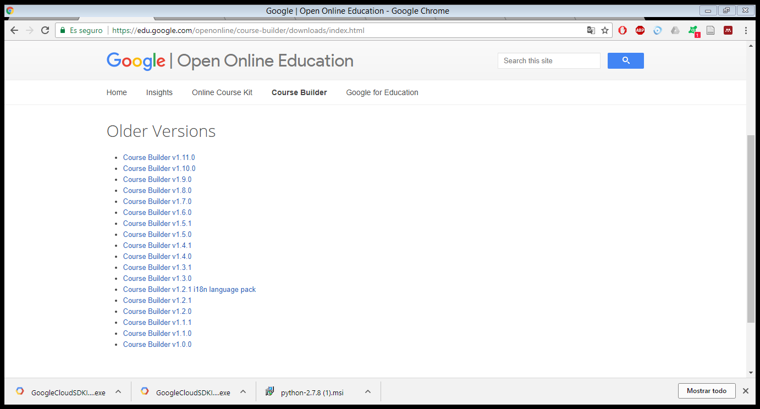

* Le damos click y esperamos a que descargue luego lo ubicamos en una carpeta y lo extraemos

1. Editamos el archivo course builder

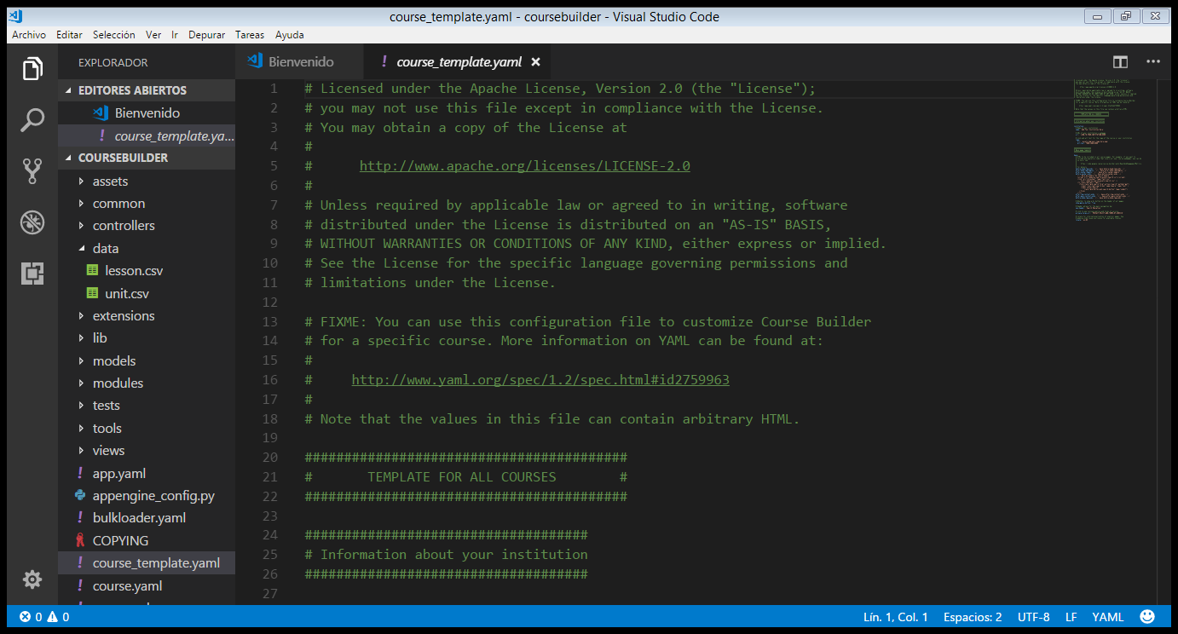

* Modificamos la institución el nombre el logo la url,

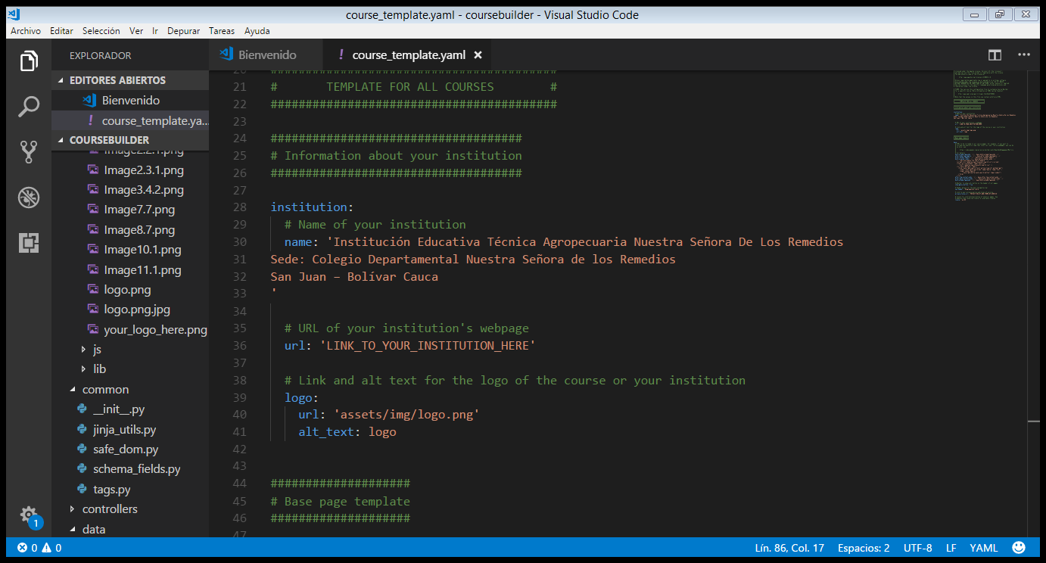

* Vamos al archivo course.

Colocamos el correo de los administradores.

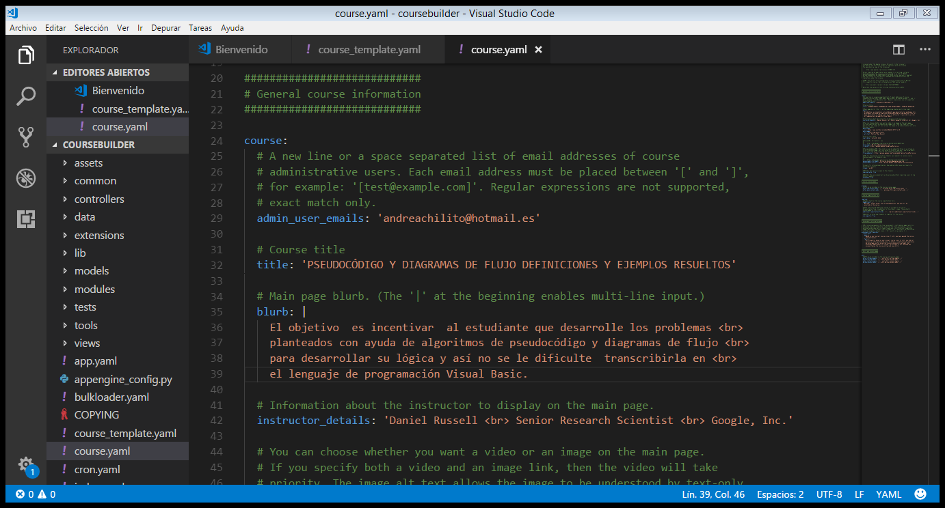

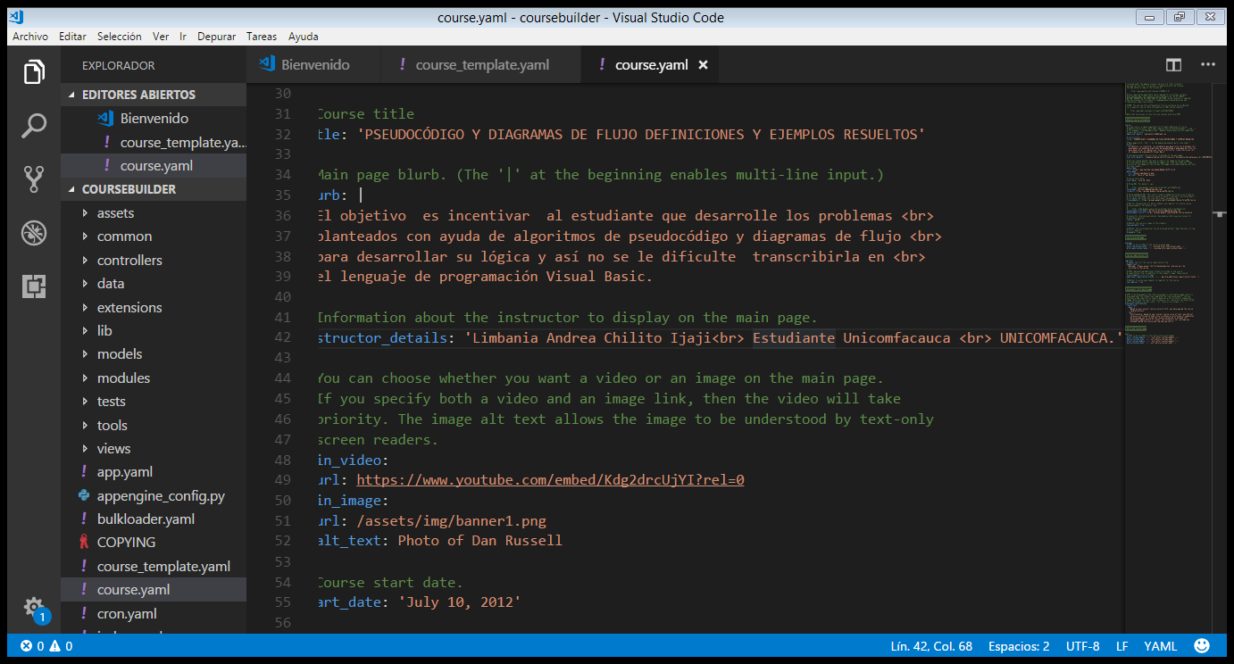

* Si se hace un foro se edita esta parte

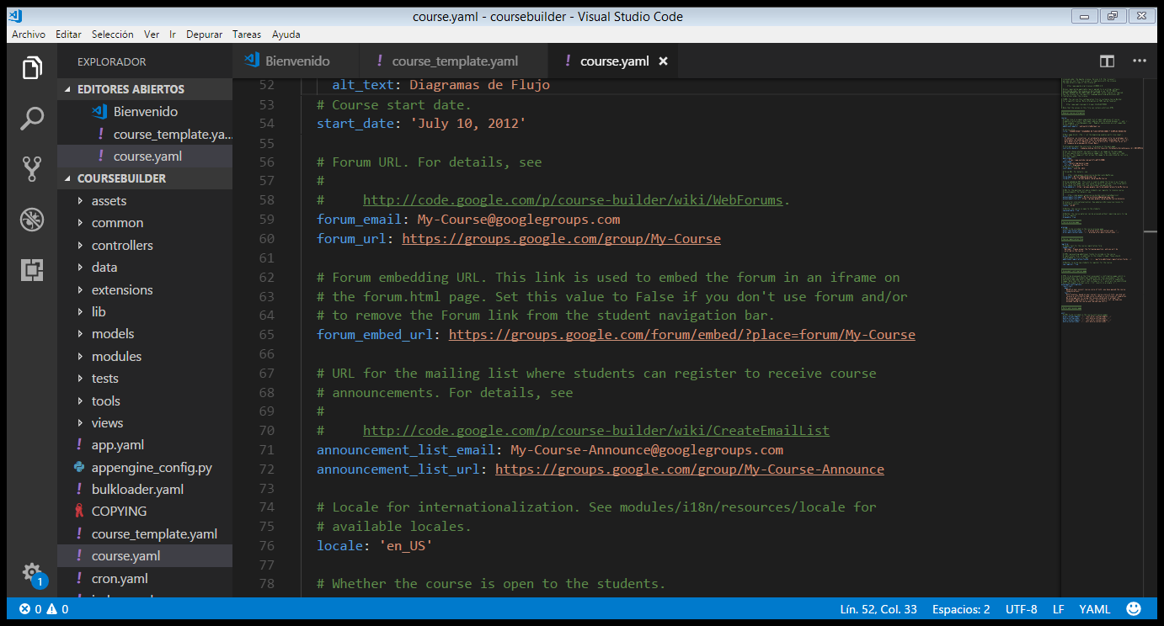

* si el alumno aprobó le aparece esta nota

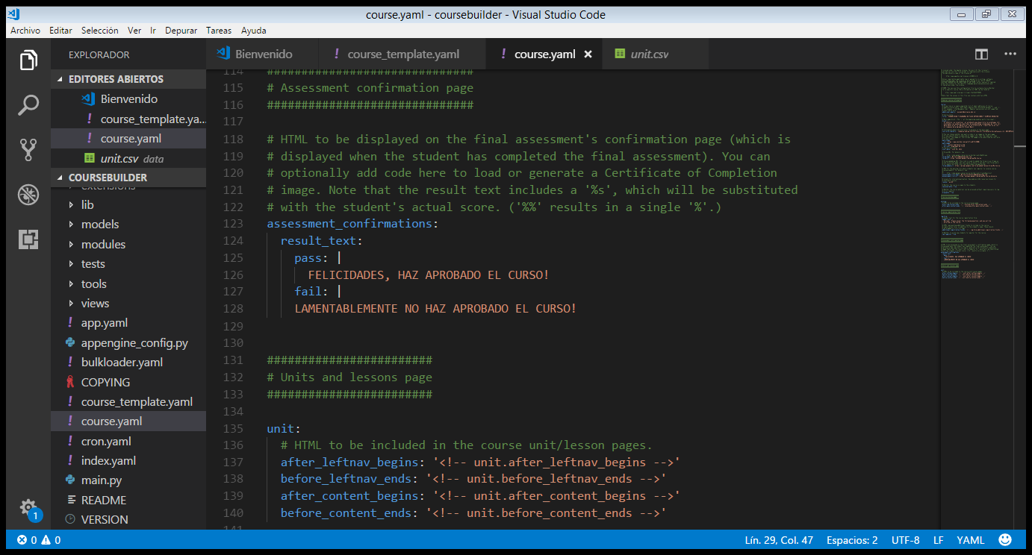

* ahora entramos en data, unit.csv y colocamos el contenido del mooc
* id es el identificador único
* type= es la unidad (A es examen, U unidad se puede integrar lesiones, O es objeto puede ser un enlace)
* unit_id = pre título examen de diagnostico
* reléase_date= a partir de cuándo está disponible
* now_available= true disponible, false no disponible

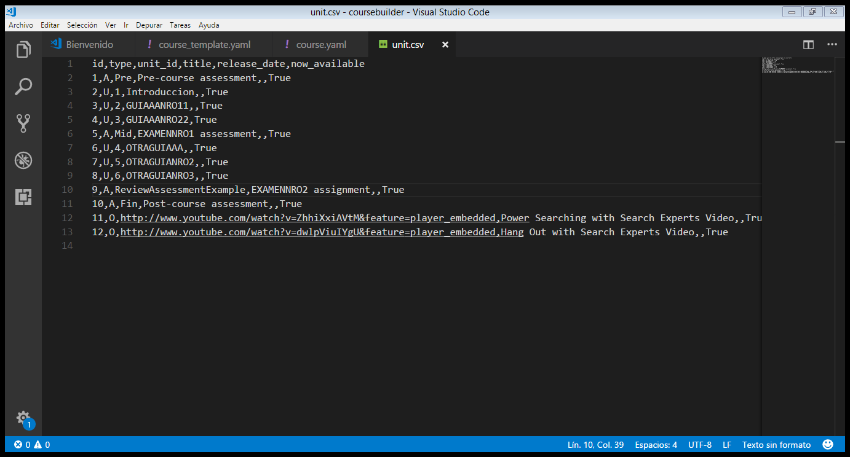

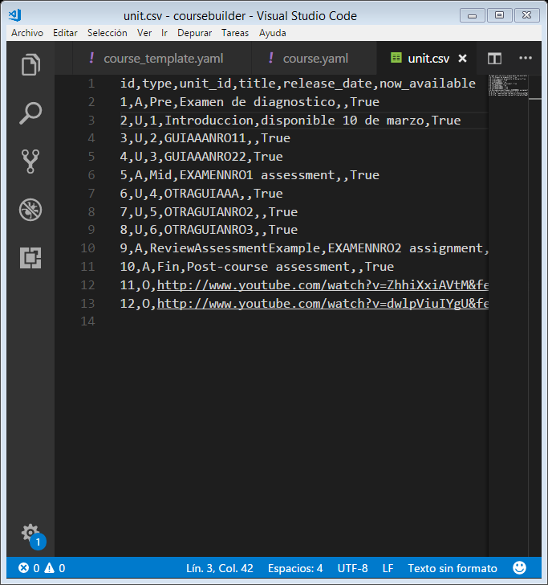

id,type,unit_id,title,release_date,now_available

1,A,Pre,Examen de diagnostico,,True

2,U,1,Introduccion,disponible 10 de marzo,True

3,U,2,GUIAAANRO11,,True

4,U,3,GUIAAANRO22,True

5,A,Mid,EXAMENNRO1 assessment,,True

6,U,4,OTRAGUIAAA,,True

7,U,5,OTRAGUIANRO2,,True

8,U,6,OTRAGUIANRO3,,True

9,A,ReviewAssessmentExample,EXAMENNRO2 assignment,,True

10,A,Fin,Post-course assessment,,True

11,O,http://www.youtube.com/watch?v=ZhhiXxiAVtM&feature=player_embedded,Power Searching with Search Experts Video,,True

12,O,http://www.youtube.com/watch?v=dwlpViuIYgU&feature=player_embedded,Hang Out with Search Experts Video,,True

Editamos tambien la lección

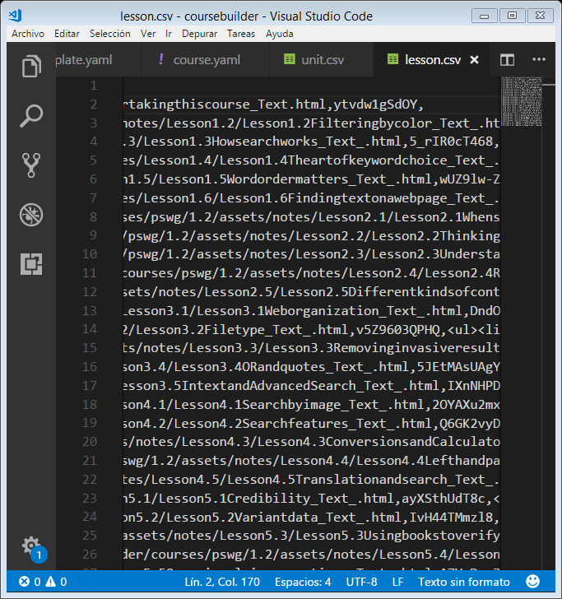

* Unit_id= único identificador
* Actividad= true es que si hay actividad
* ytvdw1gSdOY esto es se saca de youtobe despues del v=ytvdw1gSdOY

__________________________________________________________________________

unit_id,unit_title,lesson_id,lesson_title,lesson_activity,lesson_activity_name,lesson_notes,lesson_video_id,lesson_objectives

1,Introduccion,1,Introduccion,,,//www.google.com/edu/coursebuilder/courses/pswg/1.2/assets/notes/Lesson1.1/Lesson1.1Instructionsfortakingthiscourse_Text.html,ytvdw1gSdOY,

1,Introduction,2,Filter image results by color,yes,Lesson 1.2 Activity,//www.google.com/edu/coursebuilder/courses/pswg/1.2/assets/notes/Lesson1.2/Lesson1.2Filteringbycolor_Text_.html,K-0RqQWFubM,<ul><li>Apply the strategy of color filtering to find information quickly.</li></ul>

1,Introduction,3,How search works,yes,Lesson 1.3 Activity,//www.google.com/edu/coursebuilder/courses/pswg/1.2/assets/notes/Lesson1.3/Lesson1.3Howsearchworks_Text_.html,5_rIR0cT468,<ul><li>Recognize ads on a search engine results page.</li><li>Describe how the order of results on a page is determined.</li></ul>

1,Introduction,4,The art of keyword choices,yes,Lesson 1.4 Activity,//www.google.com/edu/coursebuilder/courses/pswg/1.2/assets/notes/Lesson1.4/Lesson1.4Theartofkeywordchoice_Text_.html,34ygpSN4u4c,"<ul><li>Select effective keywords: words you predict will be in your results, important words, and synonyms when appropriate.</li></ul>"

1,Introduction,5,Word order matters,yes,Lesson 1.5 Activity,//www.google.com/edu/coursebuilder/courses/pswg/1.2/assets/notes/Lesson1.5/Lesson1.5Wordordermatters_Text_.html,wUZ9lw-Z6hk,<ul><li>Identify the factors that have an effect on search queries.</li></ul>

1,Introduction,6,Finding text on a web page,yes,Lesson 1.6 Activity,//www.google.com/edu/coursebuilder/courses/pswg/1.2/assets/notes/Lesson1.6/Lesson1.6Findingtextonawebpage_Text_.html,VyhNTtNDfcM,<ul><li>Use Control-F to quickly find text on a page.</li></ul>

2,Interpreting results,1,When search results suggest something new,yes,Lesson 2.1 Activity,//www.google.com/edu/coursebuilder/courses/pswg/1.2/assets/notes/Lesson2.1/Lesson2.1Whensearchresultssuggestsomethingnew.html,R3n-_LC_wWc,"<ul><li>Utilize information in Knowledge Graph panels, Instant results, Suggestions, and Related Searches when they appear.</li></ul>"

2,Interpreting results,2,Thinking more deeply about your search,yes,Lesson 2.2 Activity,//www.google.com/edu/coursebuilder/courses/pswg/1.2/assets/notes/Lesson2.2/Lesson2.2Thinkingmoredeeplyaboutyoursearch_Te.html,d-U6Dwj7jdc,<ul><li>Recognize when search results are offering information that suggests a better/additional search.</li><li>Use 'define' to identify the meaning of words.</li><li>Use dictionary mode to define words that do not appear in traditional dictionaries.</li></ul>

2,Interpreting results,3,Understand options for different media,yes,Lesson 2.3 Activity,//www.google.com/edu/coursebuilder/courses/pswg/1.2/assets/notes/Lesson2.3/Lesson2.3Understandingyouroptionsfordifferent.html,4TcrHV1kums,"<ul><li>Use image search when it appears in search results, and use related image search to refine results.</li><li>Refine results by using different media types like videos and news.</li></ul>"

2,Interpreting results,4,Reading the Search Engine Results Page (SERP),yes,Lesson 2.4 Activity,//www.google.com/edu/coursebuilder/courses/pswg/1.2/assets/notes/Lesson2.4/Lesson2.4ReadingtheSearchEngineResultsPage_Te.html,RpT4uPfRH0E,"<ul><li>Use the page preview tool to preview results pages.</li><li>Identify the parts of a search engine result: title, web address, and snippet/abstract.</li><li>Use links within the search engine results to go directly to a sub-page of the site.</li><li>Use the site: operator to restrict results to a domain, website, or directory.</li><li>Interpret a search engine results page.</li></ul>"

2,Interpreting results,5,Different kinds of content,yes,Lesson 2.5 Activity,//www.google.com/edu/coursebuilder/courses/pswg/1.2/assets/notes/Lesson2.5/Lesson2.5Differentkindsofcontent_Text_.html,hNrzmvPA1Zo,"<ul><li>Find different kinds of content efficiently: blogs, discussions, recipes, patents, books, 3D models, scholarly sources, and legal documents.</li></ul>"

3,Advanced techniques,1,Web organization,yes,Lesson 3.1 Activity,//www.google.com/edu/coursebuilder/courses/pswg/1.2/assets/notes/Lesson3.1/Lesson3.1Weborganization_Text_.html,DndOoEVCWfI,<ul><li>Describe how operators filter results.</li><li>Use the site: operator at the top-level domain and website levels.</li><li>Use a word you expect to appear on the target page to refine results.</li><li>Use the site: operator within images and news results.</li></ul>

3,Advanced techniques,2,Filetype,yes,Lesson 3.2 Activity,//www.google.com/edu/coursebuilder/courses/pswg/1.2/assets/notes/Lesson3.2/Lesson3.2Filetype_Text_.html,v5Z9603QPHQ,<ul><li>Use the filetype: operator to find and download different kinds of documents.</li><li>Combine operators to refine searches.</li></ul>

3,Advanced techniques,3,Removing invasive results,yes,Lesson 3.3 Activity,//www.google.com/edu/coursebuilder/courses/pswg/1.2/assets/notes/Lesson3.3/Lesson3.3Removinginvasiveresults_Text_.html,HWbO_ahgrIY,<ul><li>Use the minus sign to eliminate irrelevant results.</li></ul>

3,Advanced techniques,4,OR and quotes,yes,Lesson 3.4 Activity,//www.google.com/edu/coursebuilder/courses/pswg/1.2/assets/notes/Lesson3.4/Lesson3.4ORandquotes_Text_.html,5JEtMAsUAgY,<ul><li>Use quotes to search for a phrase.</li><li>Use OR to include more than one way of expressing an idea.</li></ul>

3,Advanced techniques,5,intext: and Advanced Search,,,//www.google.com/edu/coursebuilder/courses/pswg/1.2/assets/notes/Lesson3.5/Lesson3.5IntextandAdvancedSearch_Text_.html,IXnNHPDSsoc,<ul><li>Use the intext: operator to ensure the word you want is actually on the page you find.</li><li>Use the Advanced Search user interface when appropriate.</li></ul>

4,Find facts faster,1,Search-by-image,yes,Lesson 4.1 Activity,//www.google.com/edu/coursebuilder/courses/pswg/1.2/assets/notes/Lesson4.1/Lesson4.1Searchbyimage_Text_.html,2OYAXu2mxhU,<ul><li>Identify an image with Search by Image.</li></ul>

4,Find facts faster,2,Search features,yes,Lesson 4.2 Activity,//www.google.com/edu/coursebuilder/courses/pswg/1.2/assets/notes/Lesson4.2/Lesson4.2Searchfeatures_Text_.html,Q6GK2vyDJcQ,<ul><li>Find facts quickly with shortcuts (search features).</li></ul>

4,Find facts faster,3,Conversions and Calculator,yes,Lesson 4.3 Activity,//www.google.com/edu/coursebuilder/courses/pswg/1.2/assets/notes/Lesson4.3/Lesson4.3ConversionsandCalculator_Text_.html,PP4Oe7ner2Q,<ul><li>Calculate math expressions and conversions from the search box.</li></ul>

4,Find facts faster,4,Left hand panel and Date range limiting,yes,Lesson 4.4 Activity,//www.google.com/edu/coursebuilder/courses/pswg/1.2/assets/notes/Lesson4.4/Lesson4.4Lefthandpanelanddaterangelimiting_Te.html,OJJkB1_jYdM,<ul><li>Limit results to sources from a specific time period.</li></ul>

4,Find facts faster,5,Translation and search,yes,Lesson 4.5 Activity,//www.google.com/edu/coursebuilder/courses/pswg/1.2/assets/notes/Lesson4.5/Lesson4.5Translationandsearch_Text_.html,00-WwBbjJGg,"<ul><li>Translate words, sentences, and pages.</li><li>Search pages in foreign languages using English.</li></ul>"

5,Checking your facts,1,Credibility,yes,Lesson 5.1 Activity,//www.google.com/edu/coursebuilder/courses/pswg/1.2/assets/notes/Lesson5.1/Lesson5.1Credibility_Text_.html,ayXSthUdT8c,<ul><li>Verify the credibility of information you find.</li></ul>

5,Checking your facts,2,Variant data,yes,Lesson 5.2 Activity,//www.google.com/edu/coursebuilder/courses/pswg/1.2/assets/notes/Lesson5.2/Lesson5.2Variantdata_Text_.html,IvH44TMmzl8,<ul><li>Avoid confirmation bias when conducting searches.</li></ul>

5,Checking your facts,3,Using Books to verify a quote,yes,Lesson 5.3 Activity,//www.google.com/edu/coursebuilder/courses/pswg/1.2/assets/notes/Lesson5.3/Lesson5.3Usingbookstoverifyaquote_Text_.html,YRAIdmQ1mqg,<ul><li>Search appropriate sources that offer authoritative information for the type of information you are trying to find.</li></ul>

5,Checking your facts,4,Using WHOIS and looking for other site information,yes,Lesson 5.4 Activity,//www.google.com/edu/coursebuilder/courses/pswg/1.2/assets/notes/Lesson5.4/Lesson5.4UsingWHOIS_Text_.html,Jd8PFXoDltE,<ul><li>Use WHOIS to identify who owns a particular website.</li></ul>

5,Checking your facts,5,Occasional misconceptions,,,//www.google.com/edu/coursebuilder/courses/pswg/1.2/assets/notes/Lesson5.5/Lesson5.5Occasionalmisconceptions_Text_.html,A7YmDqwZSV0,<ul><li>Distinguish between the Google products that indicate credibility and those that do not.</li></ul>

6,Putting it all together,1,Combining methods,yes,Lesson 6.1 Activity,//www.google.com/edu/coursebuilder/courses/pswg/1.2/assets/notes/Lesson6.1/Lesson6.1Combiningmethods_Text_.html,dO2vuIkFio4,<ul><li>Combine operators for stronger searches.</li></ul>

6,Putting it all together,2,Think broadly,yes,Lesson 6.2 Activity,//www.google.com/edu/coursebuilder/courses/pswg/1.2/assets/notes/Lesson6.2/Lesson6.2Thinkbroadly_Text_.html,s7QZd1hEjS4,<ul><li>Combine methods and approaches to find information efficiently.</li><li>Conduct research effectively with tools that are not traditionally used for research.</li></ul>

6,Putting it all together,3,Summary,yes,,//www.google.com/edu/coursebuilder/courses/pswg/1.2/assets/notes/Lesson6.3/Lesson6.3Summary_Text_.html,XsGpoNOVOo4,<ul><li>Identify ways to continue learning how to be an effective searcher.</li></ul>

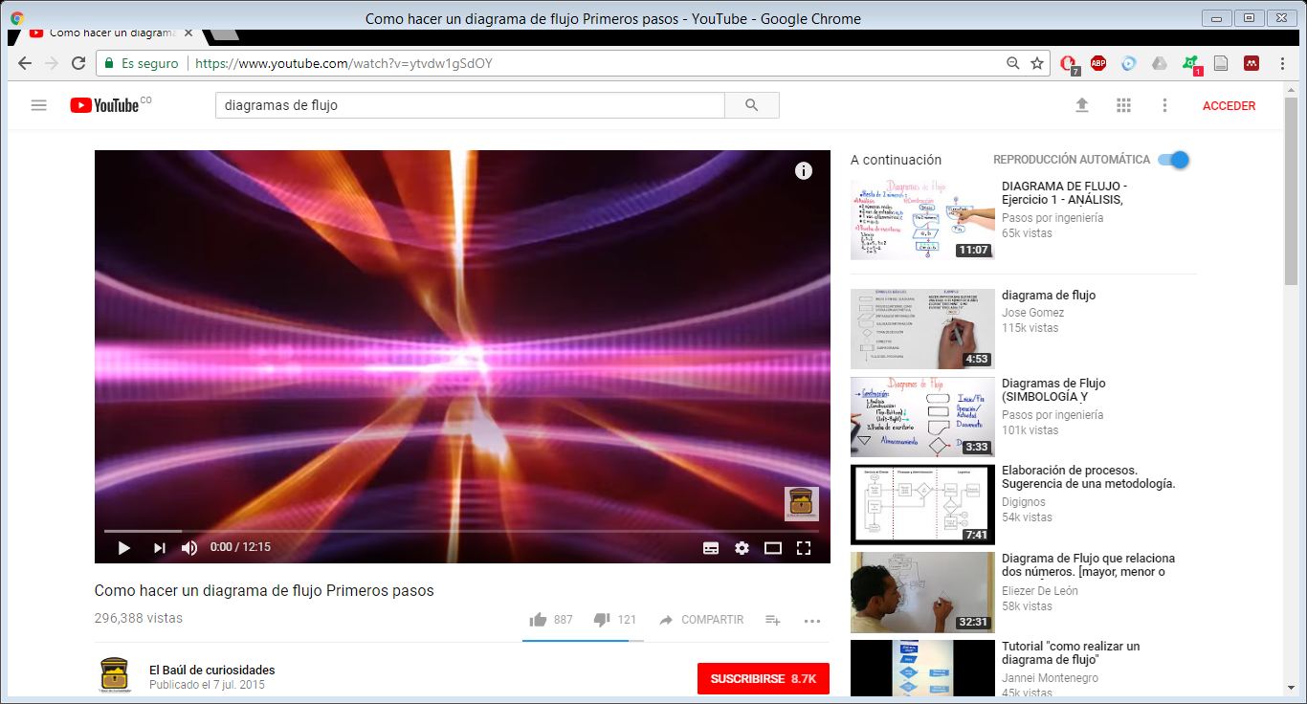

1. subir a internet

* iniciamos sección en google

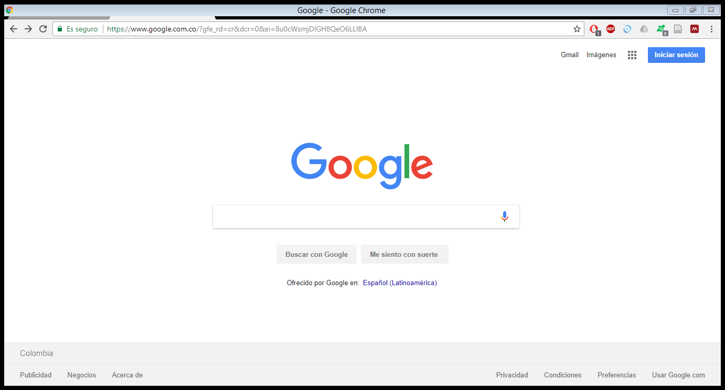

* accedemos a mi cuenta

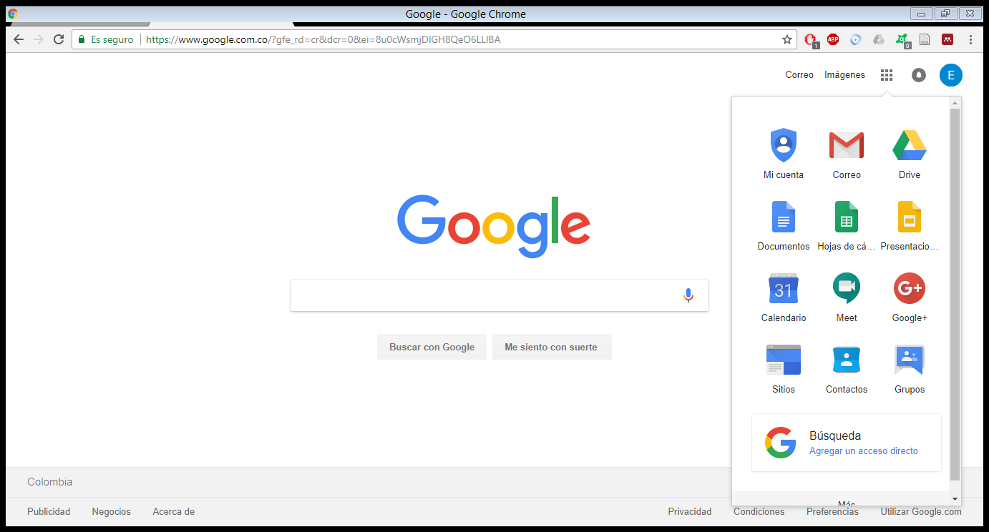

* luego vamos appengine.google.com

<https://console.cloud.google.com/appengine/start?src=ac&pli=1&project=quiet-vector-167921&organizationId=491955432757>

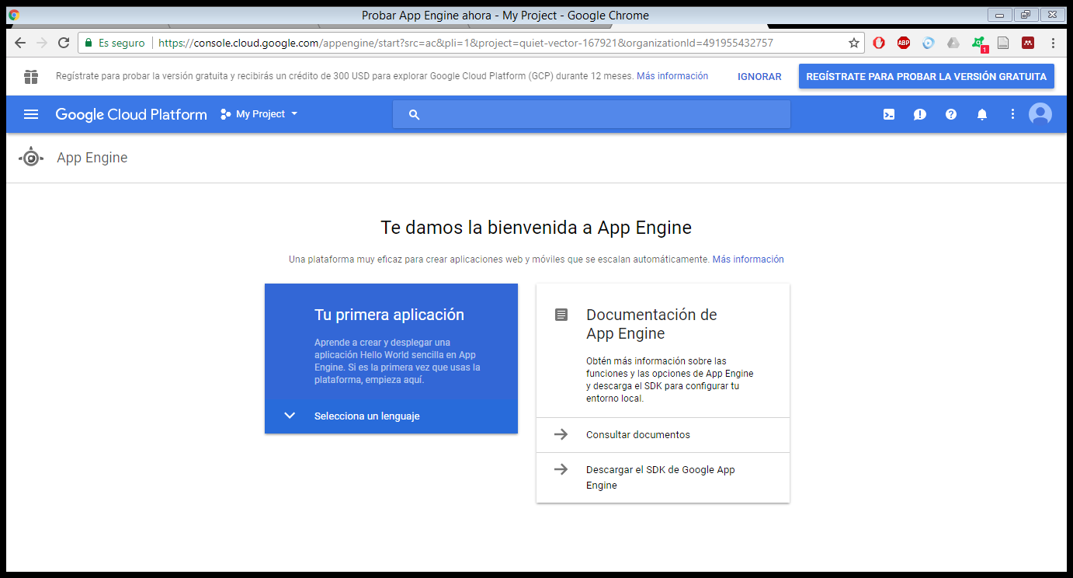

Vamos en my Project

Creamos un nuevo proyecto

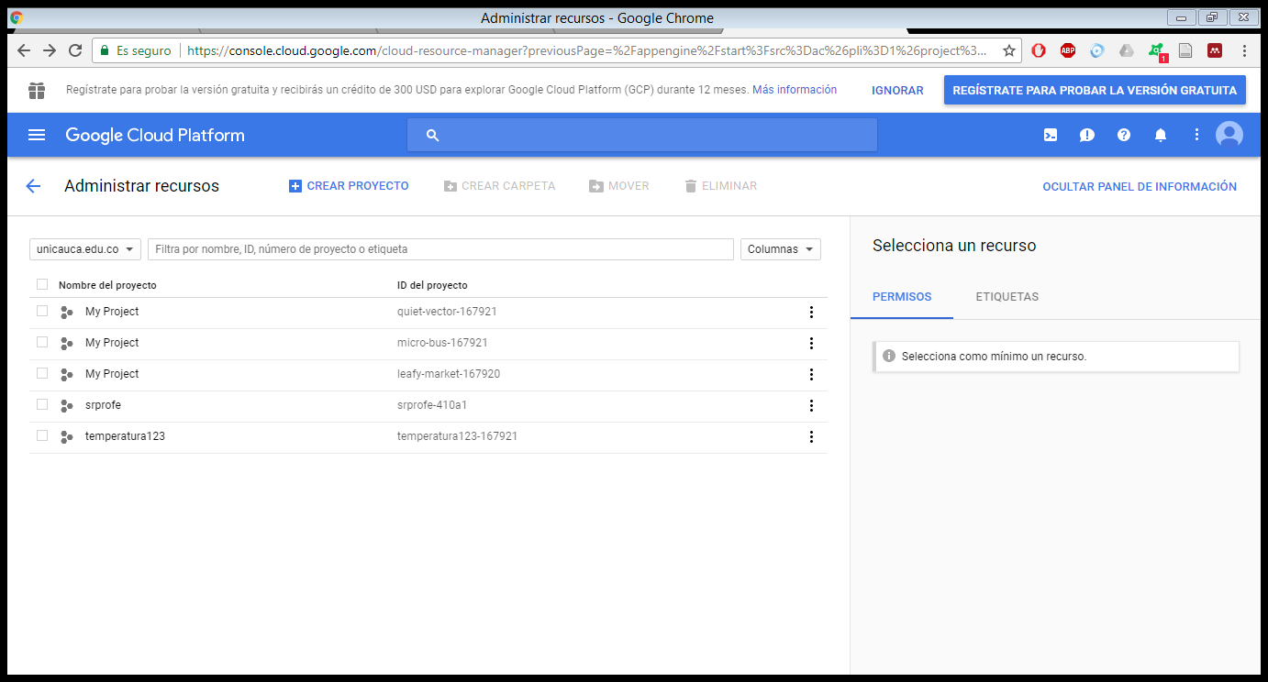

Nombre del proyecto

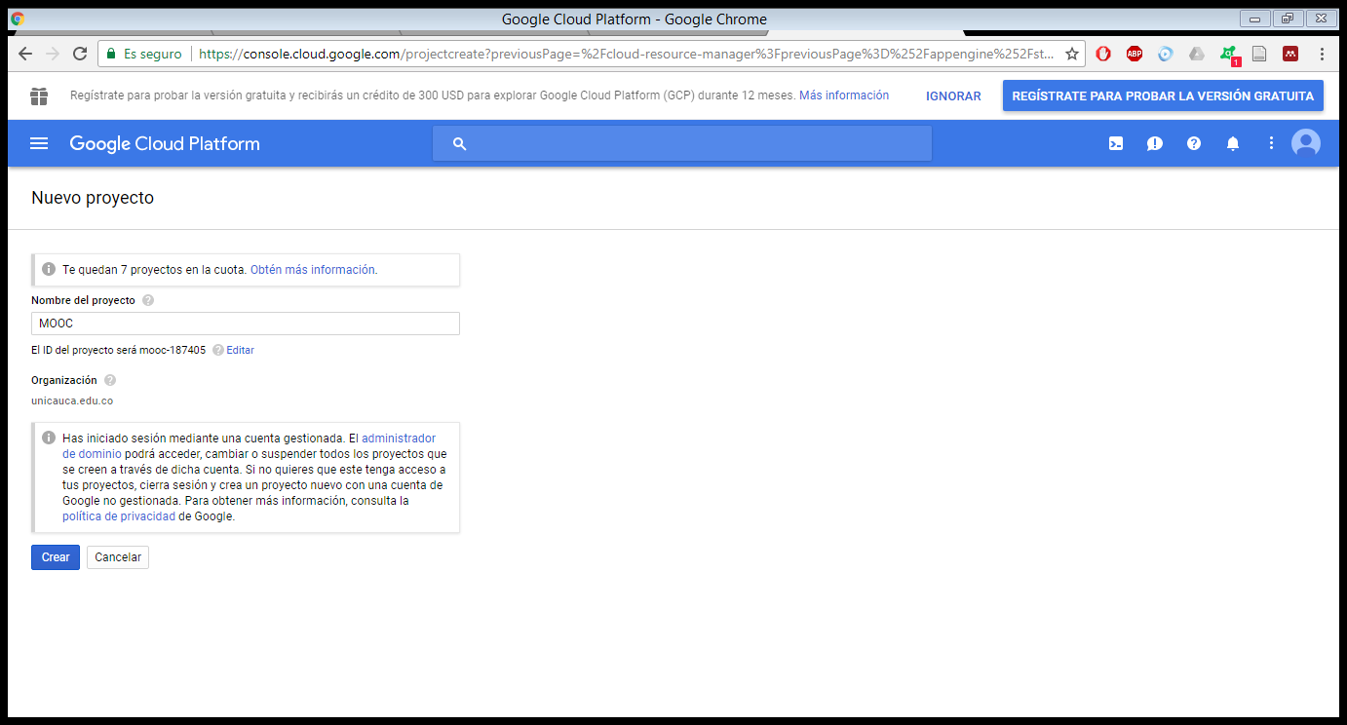

Le damos en crear

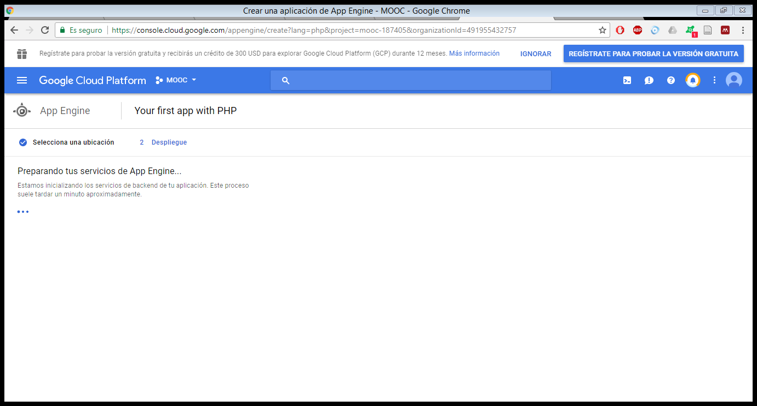

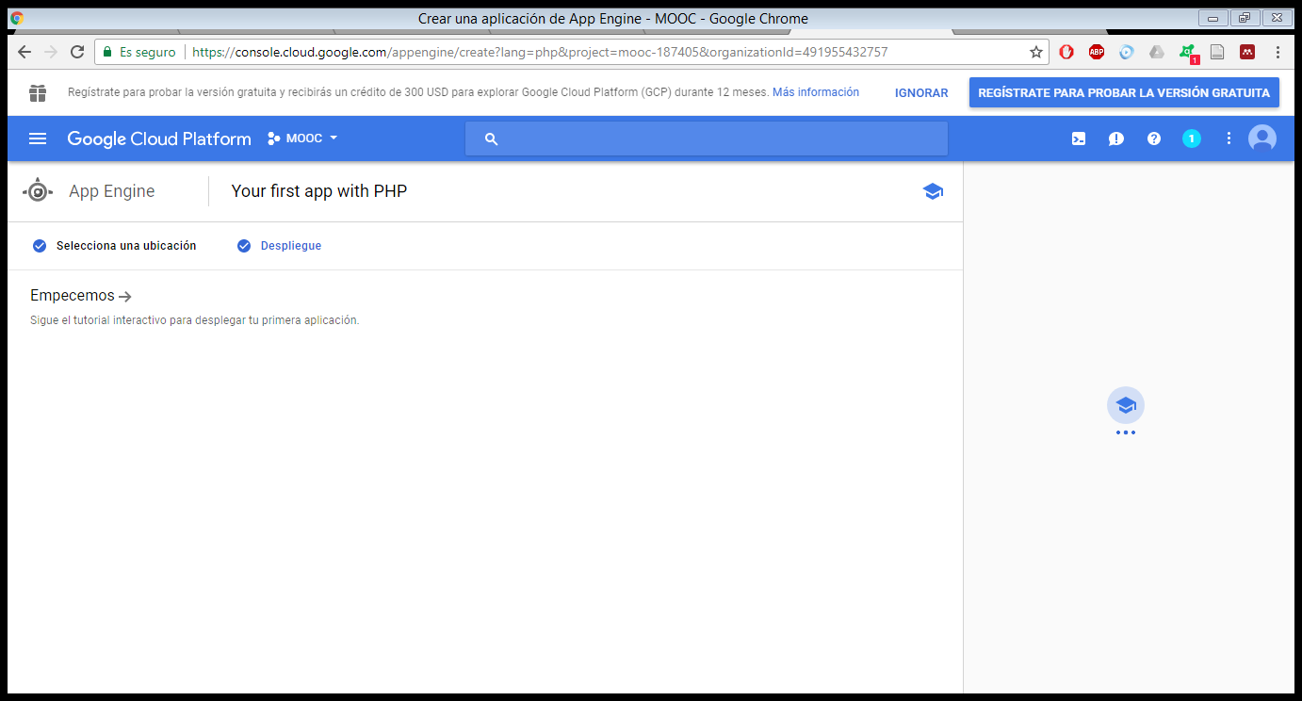

preguntas: quien va hacer la administradora correo

que va a ir en el mooc

que va a ir en el contenido del mooc

van hacer exámenes que exámenes

que guias

que títulos

van hacer un video principal

bsucar o hacer video introductorio